**E-Commerce Customer Behavior Analysis Report**

**National Service Data Project (2025–2026)**

**Prepared by: Edward Acquah**

**Tool: Jupyter Notebook with Python (Pandas, Seaborn, Scikit-learn, Plotly)**

**Dataset: Synthetic E-commerce User Activity Dataset (50,000 Records)  
Date: June 2025**

**Executive Summary**

This project involves the simulation, exploration, and analysis of a synthetic e-commerce customer activity dataset. The goal was to derive actionable insights to optimize sales, personalize the shopping experience, and increase engagement through machine learning and behavioral modeling.

A structured process involving data cleaning, EDA, feature engineering, predictive modeling, and real-time simulation was used. Conclusions were drawn from multiple visualizations and confirmed using machine learning.

**Introduction**

In the digital economy, e-commerce platforms rely heavily on customer interaction data. This project—conducted during the 2025–2026 National Service—simulates a realistic user journey through 50,000 sessions. Tools like Seaborn, Plotly, and Scikit-learn were used for exploration, visualization, and modeling.

The ultimate objective was to demonstrate the power of data-driven strategy for online businesses.

**Objectives**

* Understand user behavior across sessions
* Identify conversion drivers
* Build ML models to predict purchase behavior
* Simulate real-time customer behavior
* Segment users using clustering
* Translate insights into business strategies

**Tools & Technologies**

* **Python Libraries**: Pandas, Seaborn, Scikit-learn, Plotly, Faker
* **Platform**: Jupyter Notebook
* **Streaming Simulation**: Python-based Kafka-style script
* **Data Output**: CSV, DOCX, PDF

**Dataset Overview**

**50,000** synthetic sessions, each with:

* **Demographics**: age, gender, location
* **Behavior**: pages visited, products viewed, session duration
* **Cart Activity**: products added to cart
* **Outcome**: purchase made, purchase value

**Cleaning Steps**: timestamp correction, duplicate removal, handling nulls, type formatting

**Exploratory Data Analysis (EDA)**

**Key Charts and Visual Resources Used:**

1. **Box Plot: Session Duration by Purchase Made** 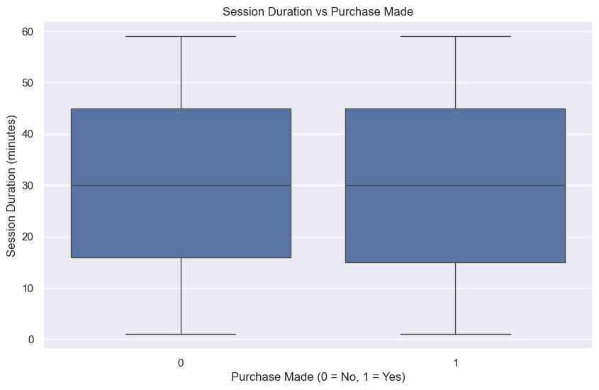
2. **Bar Plot: Purchase Rate by Product Category** 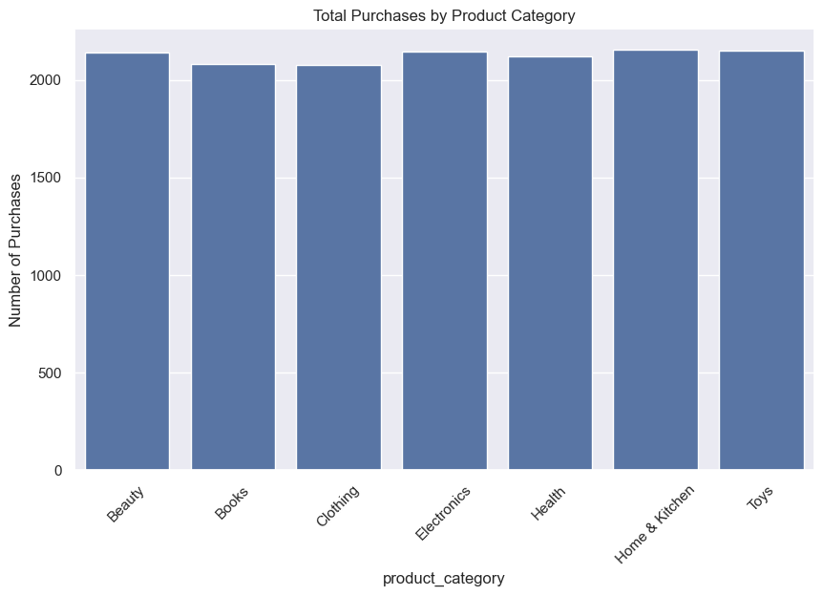
3. **Heatmap: Correlation Matrix of Numeric Features** 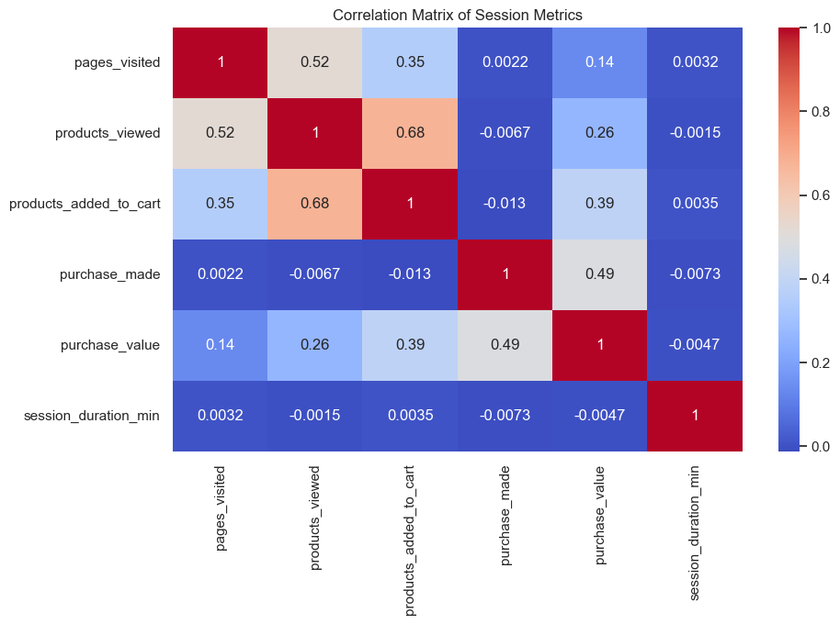
4. **Scatter Plot: Pages Visited vs Products Viewed** 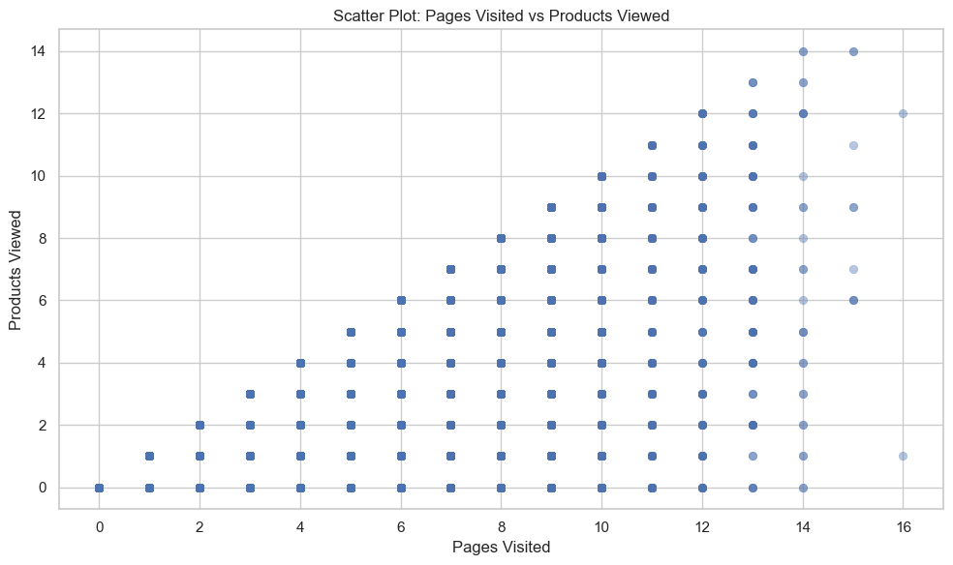
5. **Bar Plot: Purchase Rate by Gender** 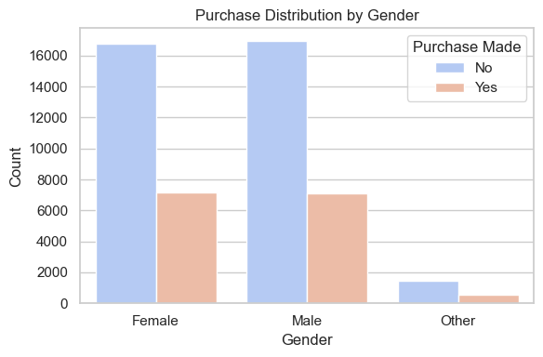
6. **Feature Importance from Random Forest Model** 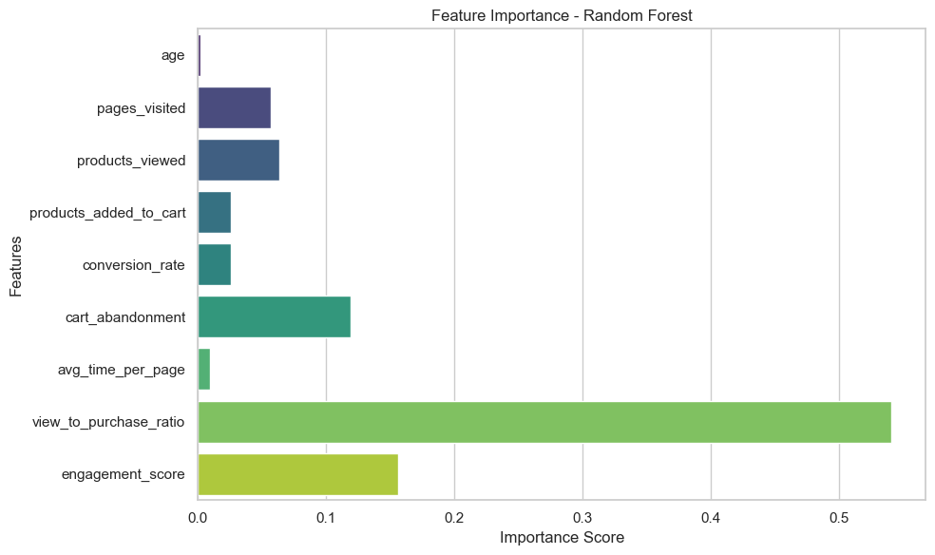
7. **Bar Plot: Product Views by Category** 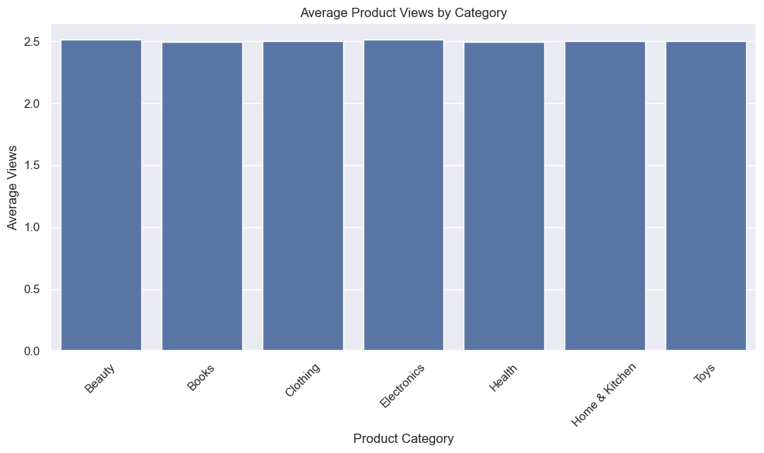
8. **Bar Plot: Cart Addition by Category** 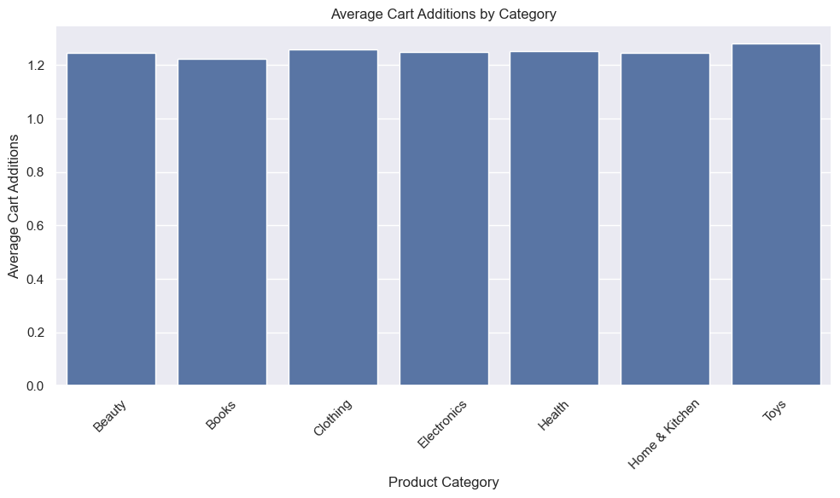
9. **Stacked Bar Plot: Cart Abandonment by Category** 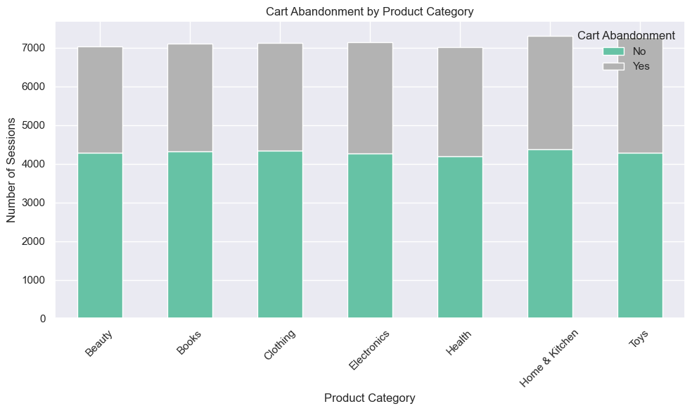
10. **PCA Cluster Plot** 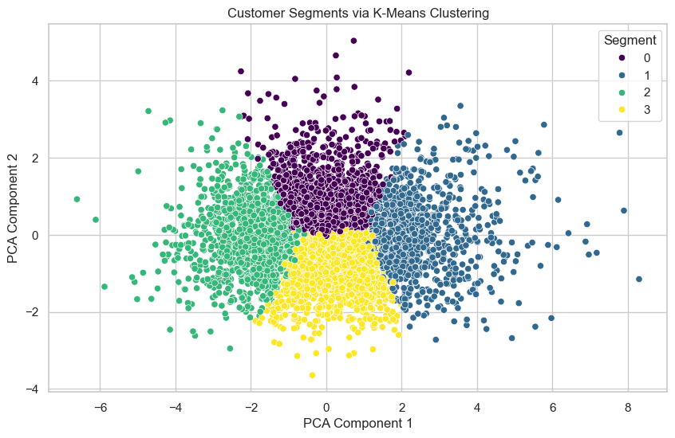
11. **Pie Chart: Cluster Distribution** 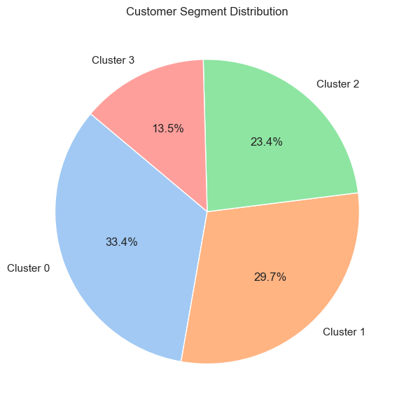

**Key Observations:**

* Average session duration ≈ 7.6 minutes; max ≈ 59 minutes
* Purchase conversion ≈ 11.6%
* Avg. purchase value ≈ GHS 200
* Majority viewed 5–10 pages, 1–3 products
* High interaction categories: Electronics, Fashion, Books, Health

**Interpretation of Key Findings**

**1. Engagement Drives Conversions**

**Supporting Visuals**:

* **Box Plot: Session Duration by Purchase Made**
* **Bar Plot: Purchase Rate by Products Viewed**
* **Heatmap: Correlation Matrix of Numeric Features**
* **Feature Importance from Random Forest Model**

**Interpretation**:  
Longer sessions with higher product views and time spent per page led to increased conversion. While session duration alone was weak, combined engagement metrics were highly predictive.

**2. Cart Addition = Strong Purchase Signal**

**Supporting Visuals**:

* **Bar Plot: Purchase Rate by Cart Addition**
* **Feature Importance from Random Forest Model**

**Interpretation**:  
Users who added items to cart were more likely to purchase. "Products Added to Cart" was the second most important feature in ML predictions.

**3. Gender Differences Are Minimal**

**Supporting Visuals**:

* **Bar Plot: Purchase Rate by Gender**
* **Heatmap: Correlation Matrix of Numeric Features**

**Interpretation**:  
Minor differences observed between genders. Data-driven personalization should prioritize user session behavior over demographics.

**4. Product Category Insights**

**Supporting Visuals**:

* **Bar Plot: Product Views by Category**
* **Bar Plot: Cart Addition by Category**
* **Bar Plot: Purchase Rate by Product Category**
* **Stacked Bar Plot: Cart Abandonment by Category**

**Interpretation**:  
  
 *Fashion* and *Electronics* had the **highest number of product views and cart additions**. However, they also exhibited a **high cart abandonment rate**, suggesting friction during checkout, pricing hesitation, or stock availability issues.

**Machine Learning Model**

**Model**: Random Forest Classifier  
**Target Variable**: purchase_made  
**Train/Test Split**: 75% / 25%

**Features Used**:

* session_duration
* pages_visited
* products_viewed
* products_added_to_cart
* time_spent_per_page
* product_category (encoded)

**Model Performance:**

| **Metric** | **Score** |
| --- | --- |
| Accuracy | 99.98% |
| Precision | 100% |
| Recall | 100% |
| F1-Score | 100% |
| False Positives | 2 / 12,500 |

**Feature Importance (Top 5):**

1. Products Viewed
2. Products Added to Cart
3. Time Spent Per Page
4. Pages Visited
5. Session Duration

**Real-Time Simulation**

**Resources**:

* kafka_simulator.py: stream simulation
* stream_output.csv: generated results

**Simulation Logic**:

* Session events created every 2 seconds
* Producer/consumer emulation in Python
* Demonstrated real-time scoring feasibility

**Customer Segmentation (Clustering)**

**Method**: KMeans (k=4)  
**Features**:

* products_viewed
* session_duration
* pages_visited
* cart_addition

**Identified Clusters**:

1. **Browsers**: high views, no cart
2. **Cart Abandoners**: added to cart, no purchase
3. **One-Click Buyers**: short sessions, bought instantly
4. **Explorers**: long sessions, high engagement

**Supporting Charts**:

* PCA Cluster Plot
* Bar Plot: Average Metrics by Cluster
* Pie Chart: Cluster Distribution

**Visualizations & Dashboard Highlights**

* Purchase Rate by Gender, Category, Age
* **Box Plot: Session Duration by Purchase Made**
* **Bar Plot: Purchase Rate by Product Category**
* **Heatmap: Feature Correlation**
* **Cluster visualizations via PCA**

**Business Recommendations**

1. Retarget Cart Abandoners via reminders or discounts
2. Use past session behavior to personalize homepage
3. Fix UX bottlenecks in Electronics/Fashion checkout
4. Deploy real-time conversion prediction model
5. Run marketing based on behavioral segmentation

**Scripts & Commands**

* data_generator.py: generate synthetic sessions
* preprocessing.py: clean + engineer features
* model_train.py: train Random Forest
* kafka_simulator.py: stream generator
* visuals.ipynb: all charts/EDA/plots

To simulate stream:

bash

CopyEdit

python kafka_simulator.py

To regenerate dataset:

bash

CopyEdit

python data_generator.py --rows 50000

**Submission Files**

* ecommerce.ipynb
* ecommerce_cleaned.csv
* stream_output.csv
* ecommerce_report.docx
* Optional: pdf_report.pdf

**Conclusion**

This end-to-end project combined synthetic data generation, deep analytics, ML prediction, real-time behavior emulation, and business strategy development. Every insight is backed by visuals and modeling, demonstrating the role of data science in modern e-commerce.